Project –

- Company 2 types –
- Service company – Client work related will provide service. Ex. TCS, Infosys, etc
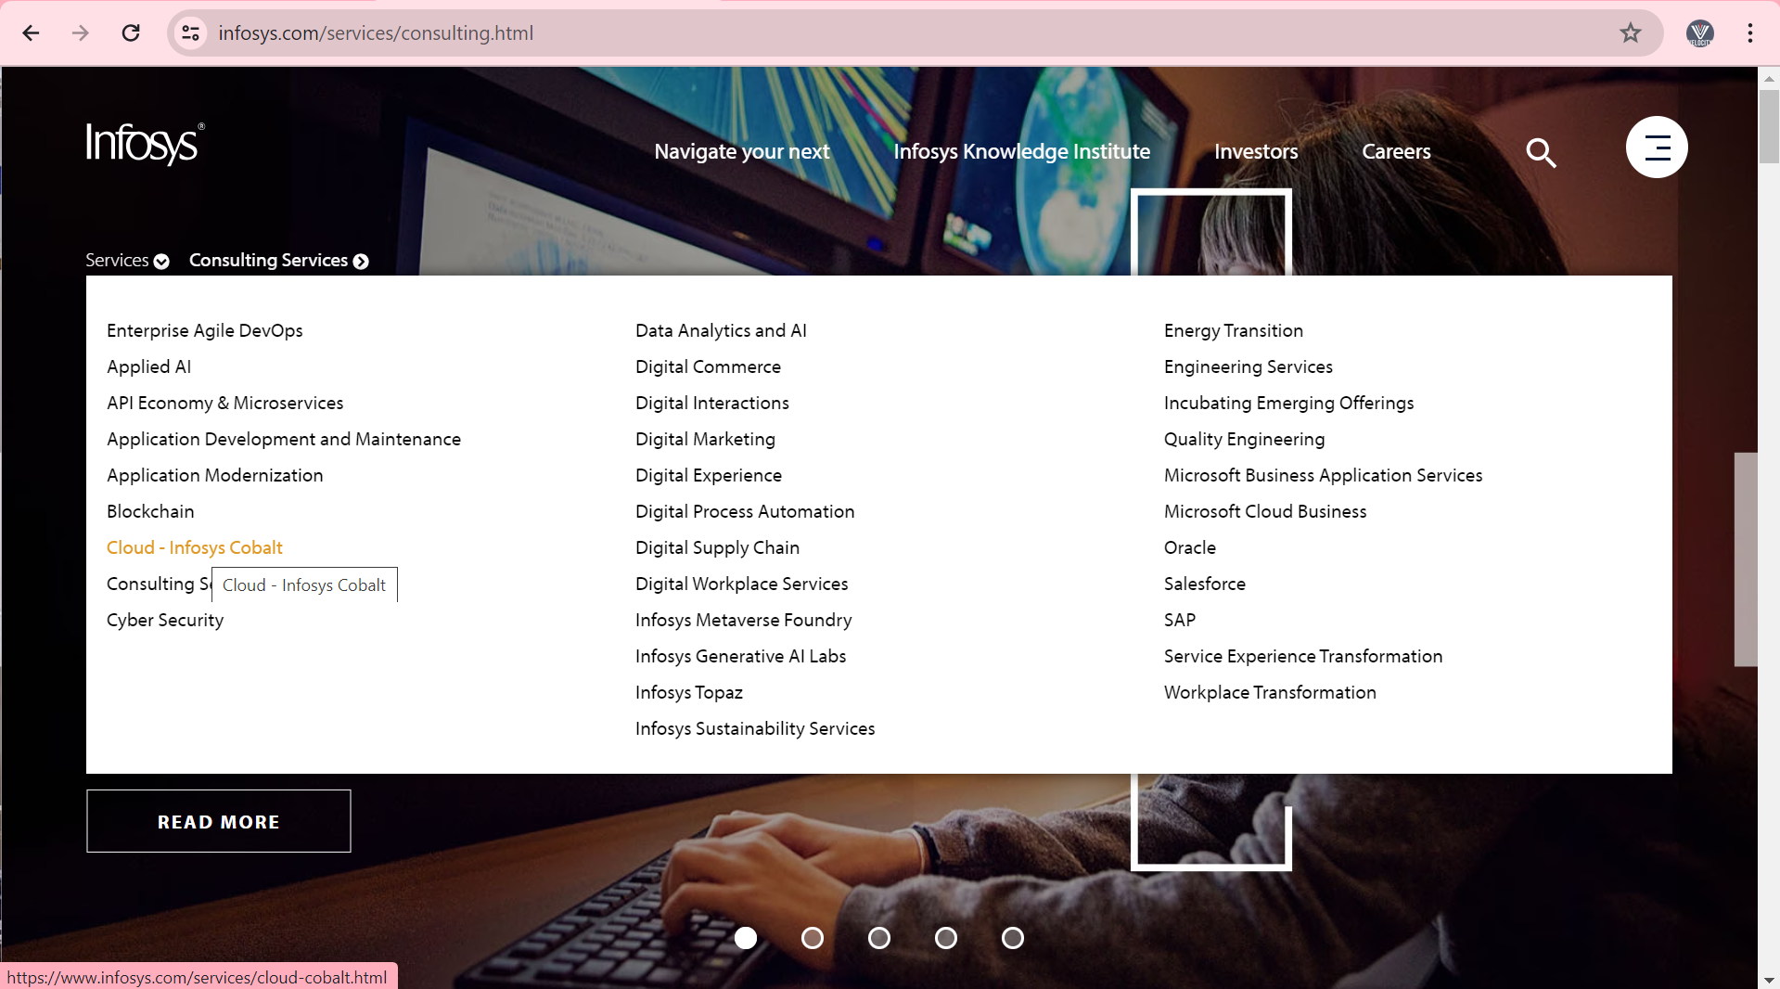

- Product based company – Company which has own product. Ex. Amdoc, PTC, etc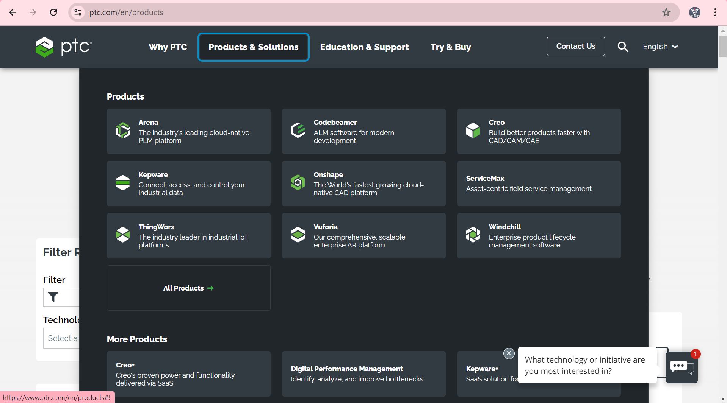

- Client (Danske Bank, Europe) Service based company (Infosys, Pune)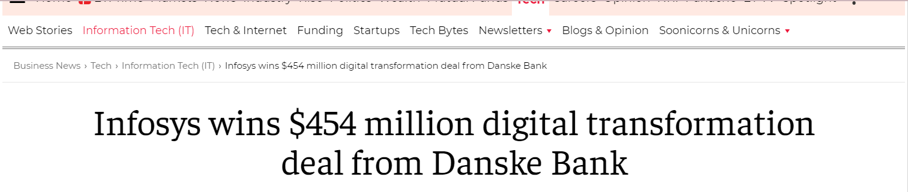

- Client requirement – Bank application service – Account opening, Money transfer throw UPI, Mobile no, etc, Account Tax saver, etc
- Infosys company – requirement – Development + Testing + Deployed/ delivery

Team Size –
- Team size 2 types team –
- Project team – In Application new feature/ functionality will be implement/added.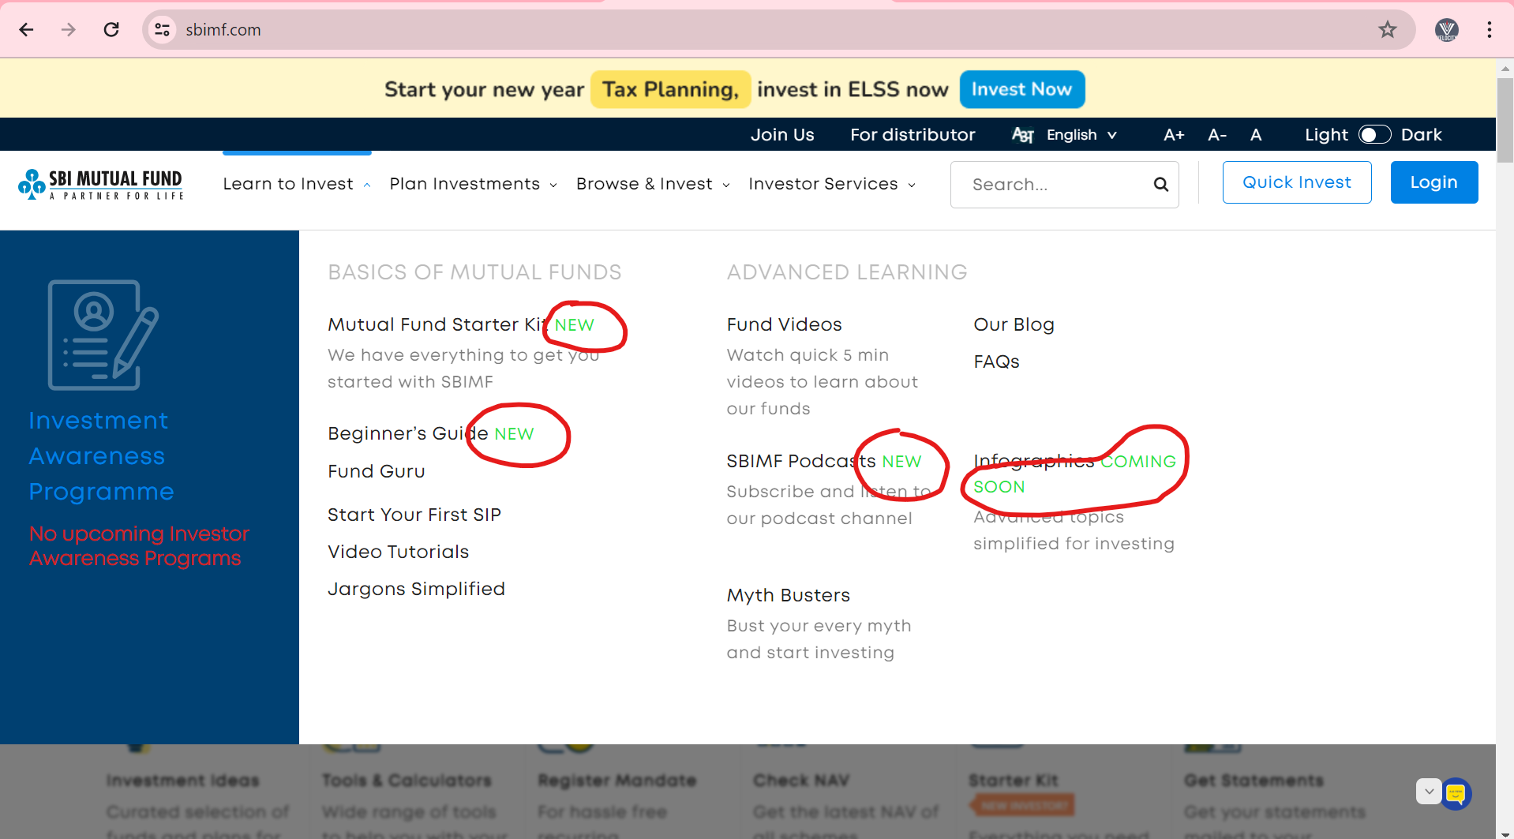
- In project team,
- Delivery Manager (DM) – DM will look into deliver process to the client.
- Business Analyst (BA) (1) – BA will do discussion with Client and take requirement from the client.
- Project manager (1) (PM/Scrum master) – PM will assign the work to developer & Tester. Project related work process, etc.
- Designer / Solution architecture / Development Lead (1) (Developer – 10 year) – Project related all technology related work will understand by designer. Designer will prepare the deign / wireframe of the new module, which need to develop.
- Developers (11) – Developer will do coding against the requirement.
- Front end (3) – Developer will the development of front part
- Backend end (6) - Developer will the development against DB.
- API Developer (2) - Developer will do development of API (Request / method)

- Tester (3) – tester will do the testing of implemented functionality.

- In my project, we have total 17 peoples.

- Support Team – Existing application – Issue/ Bug, End user quires, Support request, Enhancement, Ticket, etc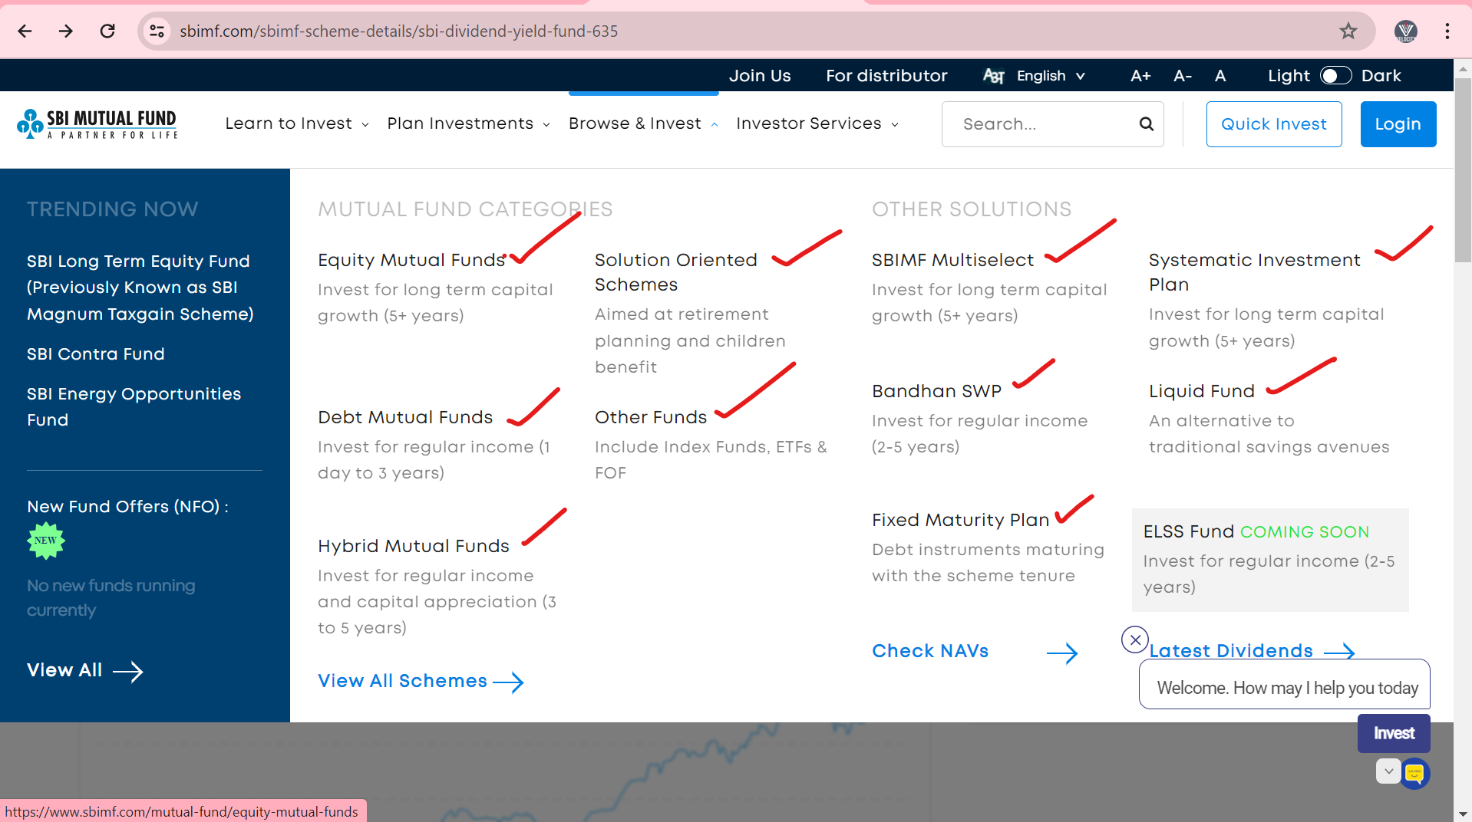

- Project manager/ Customer support manager (1) – PM will assign/ allocate the ticket/ bug/ end user request, Enache cement, etc
- Developer (3) – DO the coding against the assign the work.
- Tester (1) – Test the assign the work.

SDLC (Software development life cycle)-
- SDLC 6 stages,
- Information Gathering – In this stage, BA will communicate to client and collect all business-related requirement from the client.

- Analysis – In this stage, BA will communicate to client and collect application related requirement. In Analysis stage, BA will prepare a document related to requirement these documental are called as SRS (software requirement specification)/ FRS (functional requirement specification).
- SRS documents will contain,
- Functional requirement –
- Functional flow diagram –
- User Cases –
- Description – Details explanation about requirement
- Acceptance criteria – Shows does and don’t about the requirement.
- Screenshot/ Prototype

- BA will share these SRS documents to the project team.

- Design – Designer will prepare the design/ wireframe of the application. Designer will prepare high level design against this requirement.

- Coding – In coding stage, Developer will do the coding against this requirement. For doing coding against the requirement, we will requirement – Front End, DB Developer and API developer.

- Testing – In testing stage, these implanted functionalities will be tested by tester. In testing, if there is an issue/ bug then tester will inform to developer. Tester will test this bug after fixing by developer. After testing these implanted functionalities will be deployed to client.

- Support / Maintainer – After completion of these module / functionalities, it will handover to the support team.

Agile Process –
- Agile, it is continuing development and testing process.

Agile Meeting –
- A

IT related knowledge-

